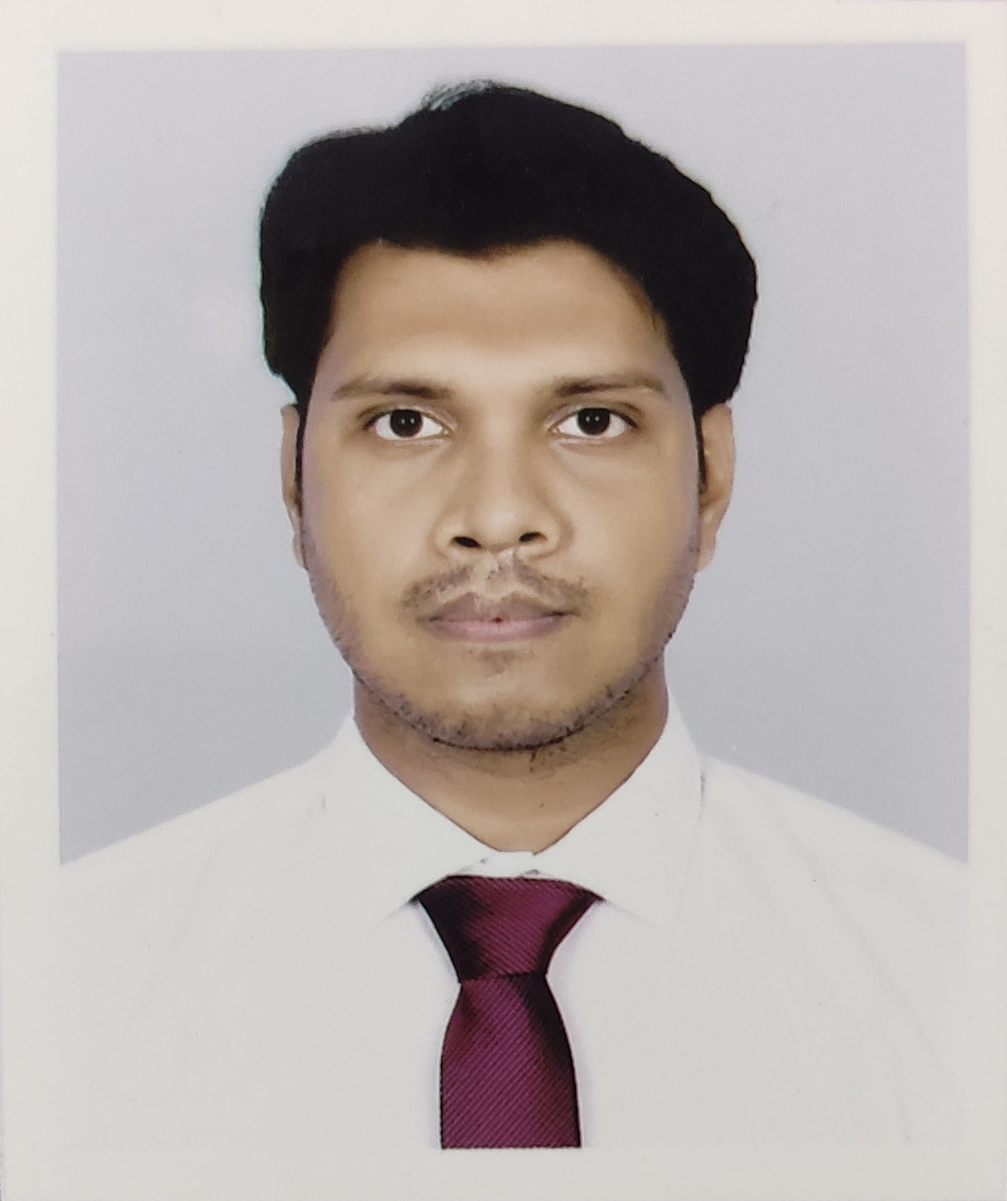
A. Professional

- Name: Saifur Rahman Shihab

- Contact no. 01995169630

- Email address: rahmansaifur223@gmail.com

- Academic record:
# | Name of the Institution | Degree/ Level  (Please mention subject to Honours & Masters level) | Passing Year
 | Southeast University | B.Sc. in CSE | 2023
 | Islami Bank Institute of Technology | Diploma in Computer | 2018
 | Motijheel Govt. Boys' High School | H.S.C in Business Studies | 2014
 | Haider Ali High School & College | S.S.C in Business Studies | 2012

- Employment record:
# | Name of Organization | Duration |  | Designation | Achievements
# | Name of Organization | From | To | Designation | Achievements
1 | Dnet | 21-Jan-24 | Present | Jr. Frontend Developer
Key Responsibilities: Implementing visual elements, Ensuring alignment of web design and user experience, Optimizing web pages, Building reusable code, Collaborating with other team members.
2
Key Responsibilities:

3
Key Responsibilities:

4
Key Responsibilities:

- The total length of experience: 3 Months

- Training Record:
# | Title/Subject of Training | Duration | Provided by | Location
1. | Web Design and Development | 6 months | Learning and Earning Development Project | Online
2. | Web Design and Development | 6 months | Cloudicon Infotech | Dhanmondi, Dhaka
3. | Professional Web Development Specialist | 6 months | Basis Institute of Technology & Management (BITM) | Panthapath, Dhaka

B. Personal

1. Full name: Saifur Rahman Shihab  2. Father’s name: Md. Siddiqur Rahman  3. Mother’s name: Rebeka Sultana  4. Date of birth: 15-June-1996  5. Present Address: #201, Central Basabo, Dhaka-1214  6. Gender: Male  7. Blood: B+ve | 8. Nationality: Bangladeshi  9. Religion: Islam  10. Passport number:  11. NID number: 9152699360  12. Disability (if applicable): None  13. Marital status: Unmarried  14.

Reference (with full contact details and email):
Name: Nodi Islam
Designation: Lecturer, Dept. of CSE
Institute: Southeast University
Phone: +880 1686609041
Email: nodi.islam@seu.edu.bd

